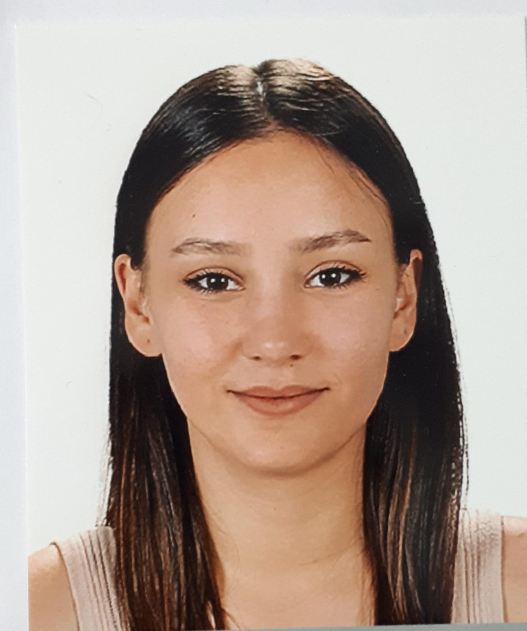

Contact
Address:
2 455 st. Bornova/İzmir 35040
Phone:
(+90) 552 820 2703
Email:
05160000484@ogrenci.ege.edu.tr
egeesunal@gmail.com
LinkedIn:
linkedin.com/in/egesunal

Languages
English – B2
German – A2

Hobbies
- Traveling
- Discover New Music
- Go To Free Community Events
- Gardening
Ege SUNAL

Personal Information
- Born: March 27, 1998 – Kırklareli
- Driving licence: B - 2021

Summary

I am studying my last semester at Ege University Faculty of Food Engineering with an average of 2.97. In all the jobs I've worked so far, I've focused on how to make my job easier and more efficient, and I've offered solutions related to them. In the same way, I want a long-term working life there, developing myself and the position I am in, no matter what sector is related to my department.

Education
2016-Present: Ege University
- Food Engineering
2012-2016: Ayvalık Anatolian Highschool

Skills
Hard Skills:
AutoCAD
MatLab/Simulig
MS Office
Introduction to basic programming
Soft Skills:
Communication skills
Leader
Powers of persuasion
Predisposition to teamwork
Be able to solve problems

Certifications
HACCP- Arya Quality Consulting Services
Sales Management Training-Istanbul Institute of Business Administration
Introduction to Basic Programming- Istanbul Institute of Business Administration
Digital Marketing Training- Istanbul Institute of Business Administration
Diction, Articulation and Effective Communication-Workshopers

